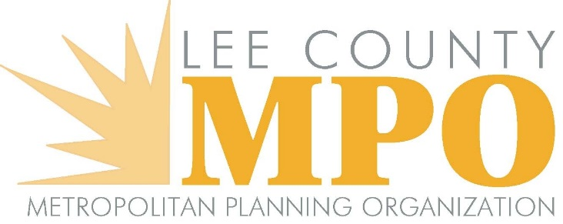
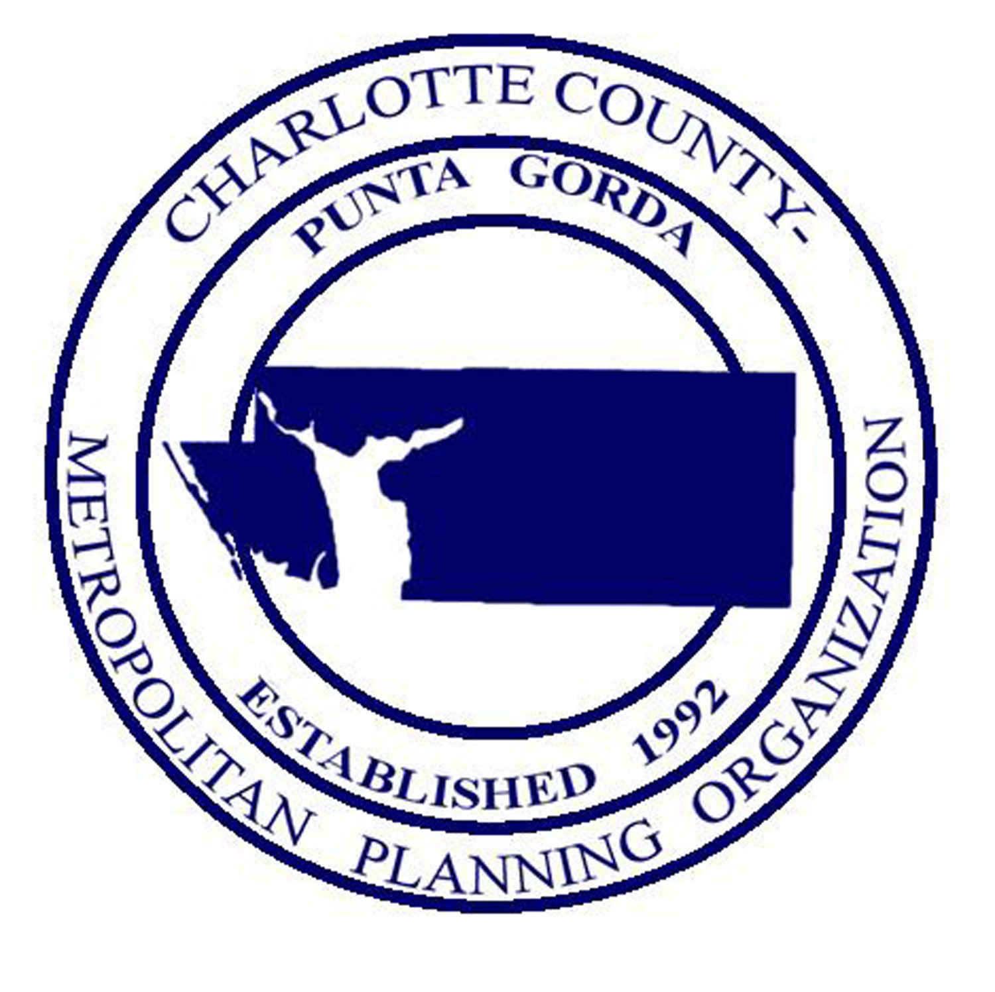

JOINT MEETING OF THE CHARLOTTE COUNTY-PUNTA GORDA METROPOLITAN PLANNING ORGANIZATION BOARD AND LEE COUNTY METROPOLITAN PLANNING ORGANIZATION BOARD

Charlotte Harbor Event and Convention Center

75 Taylor Street, Punta Gorda, Florida

Hibiscus Hall A and B, at 10:00 a.m.

Friday, February 19, 2021

MEETING MINUTES

Agenda Item #1 - Call to Order/Roll Call/Invocation

The meeting was called to order by Charlotte County Commissioner/Charlotte County – Punta Gorda MPO Chair Joseph Tiseo at 10:00 a.m. The members introduced themselves. There was a quorum for each MPO present. Those present are as follows:

Lee County MPO Board
Commissioner Frank Mann Lee County Commission
Commissioner Brian Hamman Lee County Commission
Commissioner Raymond Sandelli Lee County Commission
Councilmember Teresa Watkins Brown City of Fort Myers
Councilmember Johnny Streets, Jr. City of Fort Myers
Councilmember Fred Burson City of Fort Myers
Councilmember Darla Betzer Bonk City of Fort Myers
Councilmember Richard Johnson City of Sanibel
Mayor John Gunter City of Cape Coral
Councilmember Tom Hayden City of Cape Coral
Councilmember Dan Sheppard City of Cape Coral
Councilmember Fred Forbes City of Bonita Springs
Councilmember Laura Carr City of Bonita Springs
MPO Chair/Mayor William Ribble Village of Estero
Vice-Mayor Katy Errington Village of Estero

Charlotte – Punta Gorda MPO Board
MPO Chair/Commissioner Joseph Tiseo Charlotte County Commission
MPO Vice-Chair/Commissioner Christopher Charlotte County Commission
Constance, M.D.
Commissioner Stephen R. Deutsch Charlotte County Commission
Commissioner James Herston Charlotte County Airport Authority
Mayor Lynne Matthews City of Punta Gorda

Others in attendance included: Donald Scott, Calandra Barraco and Ranjit Gogoi with the Lee County MPO; Gary Harrell, Bekie Leslie, and Lakshmi N. Gurram with the Charlotte
County-Punta Gorda MPO; Stacy Bjordahl, Attorney for the Charlotte County-Punta Gorda MPO, Derek Rooney, Attorney for the Lee County MPO; L. K. Nandam, Wayne Gaither, Jesten Abraham, Joshua Jester and Victoria Peters (FDOT); Nicole Harris (FDOT/Stantec); Lindsay Johnson (Charlotte County); Wally Blain (Tindale Oliver); Ned Baier (Volkert); Katie Habgood (Jacobs Engineering); Peyton McLeod (Patel, Greene & Associates); Nancy Crocker (Lee County School District); Fabiana Solano (City of Punta Gorda); Persides Zambrano (Cape Coral); Rich Walker (GHD); and Charles Counsil (CC/PG MPO’s CAC).

Commissioner Herston gave an invocation, and the Pledge of Allegiance was recited.

Agenda Item #2 - Chairs’ Comments

Commissioner Tiseo asked for all cell phones to be silenced. He also asked for members to introduce themselves each time before they commented.

Agenda Item #3 - Public Comments on Agenda Items

There were no public comments on agenda items.

Agenda Item #4 - Approval of Agenda

MOTION BY COMMISSIONER CONSTANCE TO APPROVE THE AGENDA FOR THE FEBRUARY 19, 2021 JOINT LEE/CHARLOTTE MPO MEETING. SECONDED BY COMMISSIONER HAMMAN. MOTION CARRIED UNANIMOUSLY.

Agenda Item #5 - FDOT Report

Mr. L. K. Nandam with FDOT presented the FDOT Report. Mr. Nandam’s report contained information on the CARES Act Relief Bill, September Revenue Estimating Conference projections, next Revenue Estimating Conference meeting date, gas tax revenue discussions and alternate solutions, and an M-Cores update. Commissioner Tiseo asked if there were any member comments. There were none. Mr. Jesten Abraham with FDOT then provided information on the upcoming Virtual Safety Summit being held March 4. Commissioner Tiseo asked if there were any member comments. There were none.

Agenda Item #6 - I-75 Managed Lanes Study Presentation

Mr. Wayne Gaither with FDOT introduced Mr. Joshua Jester (FDOT) and Ms. Nicole Harris (FDOT/Stantec) to present this agenda item on the I-75 Managed Lanes Study. Ms. Harris provided a PowerPoint presentation with slides that included information on study update, program history, key milestones, origin/destination traffic data, virtual public meeting preview, revising the direction of the project, new project direction, planning and feasibility phase with upcoming deliverables, and upcoming events and milestones. The presentation provided by Ms. Harris can be viewed here: I-75 Managed Lanes Study Presentation. Ms. Harris asked if there were any questions. Commissioner Tiseo asked if there were any comments. Commissioner Herston, referencing slide four, asked if the distribution of linear miles is even across each corridor. Ms. Harris replied the North and South corridors are each forty miles, and she was unsure of the length of the Central corridor. Commissioner Herston then asked about slide eight regarding public involvement. Ms. Harris noted the involvement was virtual for both North and South, and public from both areas visited the project website. Commissioner Herston, referring to slide nine, then questioned if the goals of FDOT have changed over the last thirty years. Mr. Nandam replied that the process to determine future needs adjusted with practices. Mr. Nandam also mentioned long term goals, identifying goals, issues with limited funding, and dividing projects into smaller segments to move projects forward. Commissioner Herston then referred to slide ten and asked about target demand and horizon time spans. Mr. Nandam asked if Commissioner Herston was specifically referring to this program. Commissioner Herston replied that it could be confined to this program since it is the subject of the presentation. Mr. Nandam replied that this program will identify both long- and short-term needs and demand. Commissioner Herston commented that FDOT was the most consequential department in the state as well as the state’s greatest asset.
Commissioner Tiseo asked if there were any comments or additional presentations. Commissioner Constance asked about new interchanges proposed in the southern connector area. Ms. Harris said the slide was an overall handout that showed existing interchanges, and the new interchanges were not on the handout referred to. Commissioner Constance asked if the final Master Plan will be completed in 2022. Ms. Harris replied yes. Commissioner Constance asked if the reports were available for the north and south portions. Ms. Harris noted the update is similar for the north except there are new interchanges. Commissioner Constance asked about an interchange near 301 or the Bradenton River. Mr. Nandam said that interchange is near the border of District One and District Seven and most likely included in the District Seven Plan. Mr. Nandam noted District One is south of that area mentioning modifications and requests to examine interchange possibilities in the area near Del Prado Boulevard in Lee County and Everglades in Collier County.
Vice-Mayor Errington commented on the amount of litter and debris on I-75 in Lee County. Commissioner Tiseo said the concern will be noted by FDOT staff.
Commissioner Hamman questioned future planning to address congestion on I-75. Ms. Harris mentioned managed lanes and interchange improvements as well as partnering with local jurisdictions on arterials. Commissioner Hamman asked about data to assist with this. Ms. Harris commented on the StreetLight data purchased by FDOT. Commissioner Hamman asked where the most congestion on I-75 was located. Ms. Harris replied that data wasn’t available yet. Commissioner Hamman asked how quickly this could go from being in the plan to construction. Ms. Harris said the plan will be implemented in summer of 2022 with PD&E in late 2022 or 2023. Commissioner Hamman asked if there were any near future plans to address concerns. Mr. Nandam responded that the study examines short and long term improvements. He continued that the Cost Feasible update will take place later this year and projects could be inserted based on priorities. He added that the Cost Feasible process must be completed first to provide an idea how to proceed. Mr. Nandam noted it was a separate exercise for Lee County to examine the interchange improvements mentioning SR 78 and Daniels Blvd. specifically. He concluded that as far as the mainline, an update will be provided once the study is completed. Commissioner Hamman asked about the best type of feedback that could be provided. Mr. Nandam mentioned robust public engagement including providing information on problem areas to FDOT. Commissioner Tiseo commented on additional funding. Mr. Nandam noted it is helpful if local jurisdictions commit to funding their fair share. Commissioner Constance mentioned being proactive and looking at growth. Mr. Nandam commented on the start of the Master Plan study and continued collaboration for identification of roads that will fail as well as partnerships to move projects forward. He provided an example of SR 72 in Sarasota County where growth was identified, and the county worked with developers on proportionate share/impact fees.
Councilmember Laura Carr questioned planning for increased prices/materials costs. Mr. Nandam explained the gas tax and incorporation of inflation in project costs. Commissioner Constance commented on the gas tax and electric vehicles (EV) bring to questioning the best approach/practice for EV legislation. Mr. Nandam replied the best model is the pay as you go/mileage-based model. He added that several states already have an EV registration fee that goes directly to the trust fund and this may be an easy short-term solution. Commissioner Constance mentioned indexing the gas tax and fuel price increases based on weather and pipeline closures. Mr. Nandam said the average car driver pays around $300 per year in gas taxes. Commissioner Tiseo suggested impact fees could be adjusted based on gas tax revenue shortages.

Agenda Item #7 - Review and Comment on the Joint Transportation Regional Incentive Program (TRIP) Project Priority List

Mr. Scott referred to the table of Joint Trip Priorities that was included in the agenda packet and posted to the MPO websites. The table can also be viewed here: Joint TRIP Priorities. He noted the priorities will be voted on separately at the Charlotte County – Punta Gorda MPO Board meeting in May and the Lee County MPO Board meeting in June. Mr. Scott also discussed the criteria followed, regional map, Burnt Store Road as the top priority, and some TRIP funding for every segment of Burnt Store Road. Mr. Harrell added that both MPOs had previously agreed Burnt Store road would be the top priority. He also mentioned the Harborview Road project and the use of a one percent sales tax/local fund source to match the TRIP funds. Commissioner Tiseo asked if there were any member comments. Commissioner Deutsch referred to previous joint meetings and complimented all on the coordination between Charlotte County and Lee County. Commissioner Tiseo asked if there were any other comments. There were none.

Agenda Item #8 - Burnt Store Road Corridor Improvements - Status Update
Mr. Harrell commented on the Burnt Store improvements in Charlotte County. He noted the Phases I and III of Burnt Store Road are complete with Phase III limits from a point just north of the Lee County Line to a point north of Zemel Road and Phase I limits from south of Notre Dame Blvd. to US 41. He added Phase II, from a point north of Zemel Rd to a point south of Notre Dame Blvd, is currently under construction and is scheduled to be completed in the spring of 2022. He mentioned the project was fully funded in the CIP and this enabled relative ease to provide the required fifty percent match for TRIP funding. Mr. Harrell then introduced Ms. Lindsay Johnson, the Charlotte County manager of the project, to provide a PowerPoint presentation of the Charlotte County progress with Phase II. Ms. Johnson’s presentation included slides with information on project cost, design, roadway alignment, schedule, and construction operations. Ms. Johnson’s presentation can be viewed here: Charlotte County Burnt Store Phase II. She asked if there were any questions. Commissioner Tiseo asked if there were any comments. There were none. Mr. Scott continued this agenda item with a presentation of the Lee County improvements to the Burnt Store corridor. Mr. Scott gave a brief PowerPoint presentation that included slides with information on a map of the segments, southern segment description, middle and north segment description, and Van Buren to North of Charlotte County line description. Mr. Scott’s presentation can be accessed here: Lee County Burnt Store Improvements. He asked if there were any questions. Commissioner Tiseo asked if there were any comments. There were none.

Agenda Item #9 - Status of Planned SR 31 Improvements

Mr. Scott began the PowerPoint presentation for this agenda item on the Planned SR 31 Improvements with slides that provided information on SR 31 from SR 80 to SR 78 description, SR 31 from SR 78 to Cook Brown description, typical section illustration, public meeting PD&E information, and SR 78 from I-75 to SR 31 information. Mr. Harrell then continued the presentation with details on the roundabout planned at the high crash intersection of SR 31 at CR 74/Bermont Road and project description. Commissioner Mann asked about the status of the roundabout at CR 74. Mr. Harrell responded that it is currently programmed for construction in the Work Program so it should be moving forward in the next few years. Commissioner Mann mentioned the initial traffic impact of Babcock Ranch in Lee County and thanked FDOT for including him in the coordination meetings. Commissioner Deutsch noted the large amount of accidents in the area of the planned roundabout and asked FDOT to consider two lanes in both directions on SR 31. Commissioner Mann noted this intersection has record fatalities and the traffic light hasn’t made a difference. Commissioner Constance commented on the alignment. Mr. Nandam noted the alignment was based on avoidance of the existing gas line. He also mentioned meeting with Commissioner Mann in Lee County as well as creating a working group with Lee County and Charlotte County staff for continued collaboration with Babcock Ranch. Commissioner Tiseo referenced the developer agreement for Babcock Ranch that takes into account all of the phases through completion and asked if the Lee County portion was taken into account. Mr. Nandam said there are incremental re-evaluations that ensure input at all stages. Commissioner Tiseo deferred to MPO staff to take notes and be involved. Mr. Harrell commented that Lee and Charlotte County staffs would work with FDOT and the MPOs for coordination. Commissioner Mann asked about the trigger mechanisms as to who pays for what and when. He also mentioned there would be numerous decisions ahead about cost allocations noting much of the traffic from Babcock Ranch currently flows south into Lee County for supplies. Commissioner Tiseo mentioned that one of the triggers is certificate of occupancies. He continued that Babcock Ranch is also developing the commercial property with the recent opening of Publix and Starbucks with the idea to provide all of the community necessities on site. Mr. Scott mentioned one additional slide in the presentation that provided information on extending the northern end of SR 31 back into US 17 near Bartow. The entire presentation can be viewed here: SR 31 Improvements. Commissioner Tiseo asked if there were any more comments. There were none.

Agenda Item #10 - I-75 Purple Heart Highway Initiative

Mr. Harrell explained the work and goals of the Military Order of the Purple Heart. He referred to a map of the Purple Heart Highways/Trails in Florida and reviewed the designations. The map can be viewed here: Purple Heart Highway/Trail Map Florida. He added that the possible designation of I-75 as a Purple Heart Memorial Highway in both Charlotte and Lee Counties was discussed at previous joint meetings and a joint resolution was approved in 2019. He noted the end result is to have all of I-75 in Florida designated as a Purple Heart Highway. He added this is not an MPO action but can be coordinated for each county. Commissioner Deutsch noted there is a large number of veterans in Charlotte County and support would be welcomed. Councilmember Fred Forbes mentioned Senate Bill 408 from Senator Bradley of Clay County that could easily include an amendment for Purple Heart designation of I-75 in Lee and Charlotte Counties. He added that the office staff of Senator Rodrigues has a copy. Commissioner Tiseo clarified that there was no action on this item. Mr. Harrell affirmed there was no MPO action, but this could be taken back to each county for support. Mayor Lynne Matthews said that she would present the information to Senator Albritton for support. Commissioner Tiseo noted there was a delegation meeting coming up. Commissioner Deutsch added both have supported this in the past. He asked if there were additional comments. There were none.

Agenda Item #11 - Next Meeting Date
Mr. Harrell commented the joint meeting was originally held in November but due to many items not being ready at that time it was switched to February. He added that if February was agreeable, then the joint meeting could be continued in February of next year. Mr. Scott said the exact date would be February 18, 2022. Commissioner Tiseo asked if the venue would be switched. Mr. Harrell explained that normally the venue would be switched between counties each year, but due to COVID-19 related issues with securing a large enough venue, it was again held in Charlotte County. Mr. Harrell continued that it would most likely be held in the same venue, the Charlotte Harbor Event Center, next year as well. Commissioner Tiseo reiterated the meeting would be held on February 18, 2022 in Charlotte County and delegated MPO staff to work out the details. He asked if there were any comments. There were none.

Agenda Item #12 - Staff Comments
Mr. Harrell thanked everyone for attending. Mr. Scott thanked Charlotte County- Punta Gorda MPO for arranging the venue.

Agenda Item #13 - Member Comments
Commissioner Deutsch thanked everyone for attending, invited them to view Charlotte County, and wished safe travels for all. Councilmember Carr thanked Charlotte County – Punta Gorda MPO for hosting. Commissioner Tiseo reminded those present about continuing Babcock coordination.

Agenda Item #14 - Public Comments
There were no public comments.

Agenda Item #15 - Adjournment
The meeting was adjourned at 11:33 a.m.

An audio recording of the entire meeting can be accessed here: Joint MPO February 19, 2021

All interested parties are invited to appear and be heard on each of the above items. Written comments filed with the MPO will be considered. Copies of all of the above proposed documents are available by calling the Lee MPO Office at 239-244-2220 or the Charlotte County-Punta Gorda MPO Office at 941-883-3535. THIS NOTICE is published pursuant to the requirements of the Federal Laws, Florida Statutes and MPO Policy. NO STENOGRAPHIC RECORD BY A CERTIFIED COURT REPORTER IS MADE OF THIS MEETING. ACCORDINGLY, ANY PERSON WHO MAY SEEK TO APPEAL ANY DECISIONS INVOLVING THE MATTER NOTICED HEREIN WILL BE RESPONSIBLE FOR MAKING A VERBATIM RECORD OF THE TESTIMONY AND EVIDENCE AT THIS MEETING UPON WHICH ANY APPEAR IS TO BE BASED. Public participation is solicited without regard to race, color, national origin, age, sex, religion, disability, or family status. Persons who require special accommodations under the Americans with Disabilities Act or persons who require translation services (free of charge) should contact the Lee MPO at 239-244-2220 or the Charlotte County-Punta Gorda MPO at 941-883-3535 at least seven (7) days prior to the meeting. The MPO’s planning process is conducted in accordance with Title VI of the Civil Rights Act of 1964 and related statutes. Any person or beneficiary who believes he/she has been discriminated against because of race, color, religion, sex, age, national origin, disability or family status may file a complaint with the LEE MPO Title VI Coordinator Calandra Barraco at (239) 244-2220 or by writing her at P. O. Box 150045, CAPE CORAL, FLORIDA 33915 OR the Charlotte County-Punta Gorda MPO Title VI Coordinator Wendy W. Scott at (941) 883-3535 or by writing her at 25550 Harbor View Road, Suite 4, Port Charlotte, FL 33980

