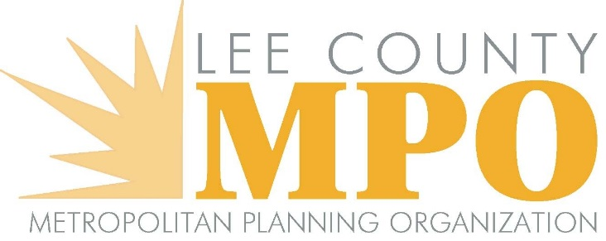

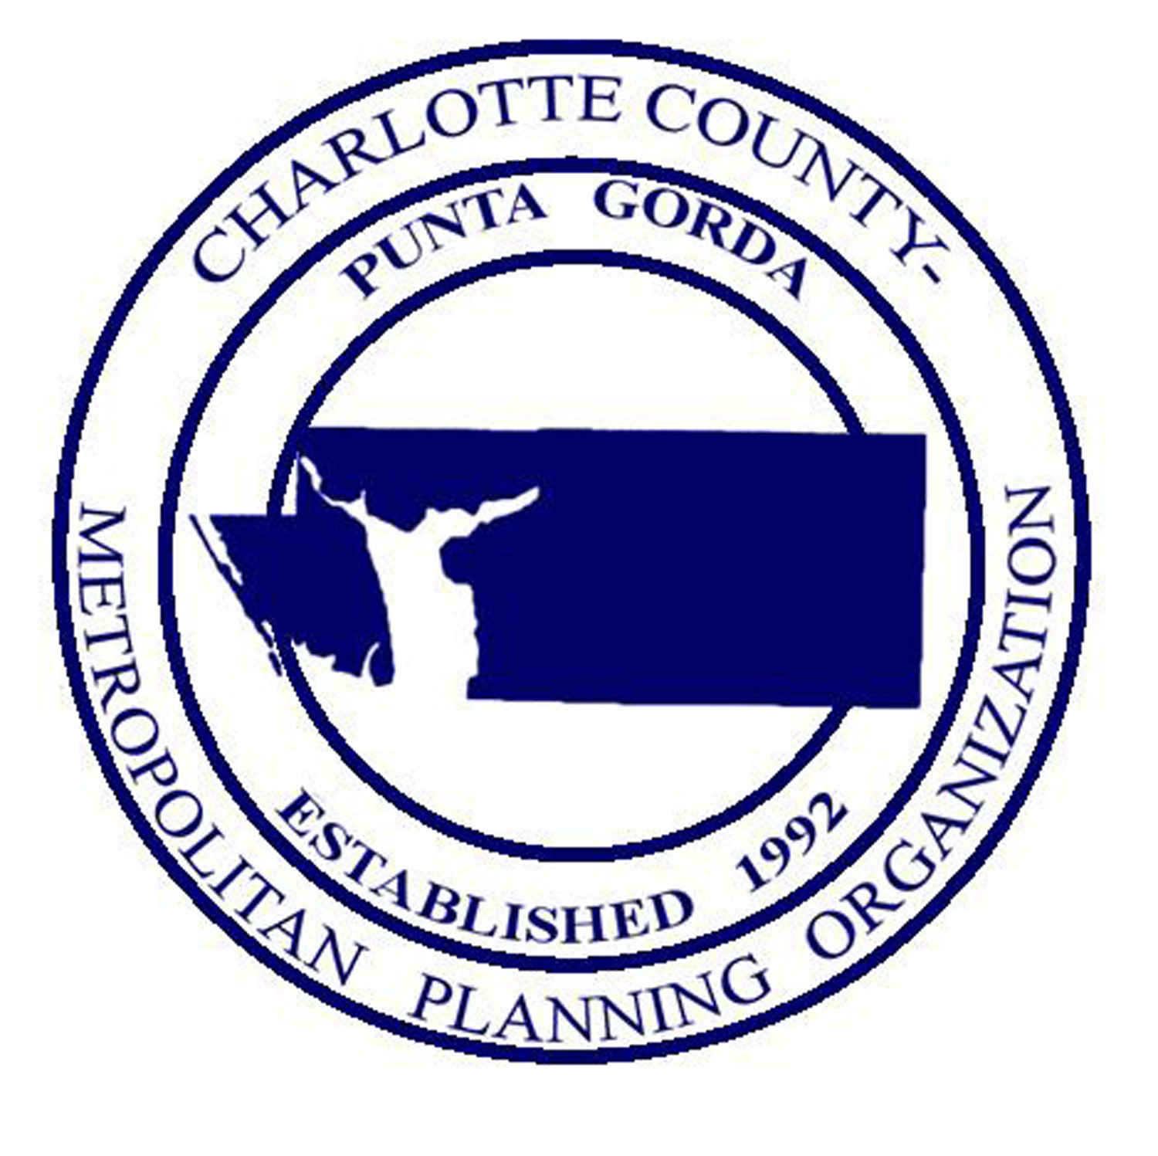

**JOINT MEETING OF THE CHARLOTTE COUNTY-PUNTA GORDA METROPOLITAN PLANNING ORGANIZATION BOARD AND LEE COUNTY METROPOLITAN PLANNING ORGANIZATION BOARD**

#### Burnt Store Road Presbyterian Church

#### 11330 Burnt Store Road, Punta Gorda, Florida

#### Stewart Hall at 10:00 a.m.

#### Friday, February 18, 2022

**MEETING MINUTES**

**Agenda Item #1 - Call to Order/Roll Call/Invocation**

The meeting was called to order by Charlotte County Commissioner/Charlotte County – Punta Gorda MPO Chair Christopher Constance at 10:02 a.m. The members introduced themselves. There was a quorum for each MPO present. Those present were as follows:

**Lee County MPO Board**

MPO Chair/Councilmember Teresa Watkins Brown City of Fort Myers

Commissioner Frank Mann Lee County Commission

Commissioner Brian Hamman Lee County Commission

Councilmember Darla Betzer Bonk City of Fort Myers

Mayor John Gunter City of Cape Coral

Councilmember Dan Sheppard City of Cape Coral

Councilmember Keith Long City of Cape Coral

Councilmember Tom Hayden City of Cape Coral

Councilmember Jessica Cosden City of Cape Coral

Vice-Mayor Richard Johnson City of Sanibel

Councilmember Fred Forbes City of Bonita Springs

Councilmember Laura Carr City of Bonita Springs

Councilmember Jon Mclain Village of Estero

**Charlotte – Punta Gorda MPO Board**

MPO Chair/Commissioner Christopher Constance, M.D. Charlotte County Commission

MPO Vice-Chair/Commissioner Stephen R. Deutsch Charlotte County Commission

Commissioner Joseph Tiseo Charlotte County Commission

Commissioner James Herston Charlotte County Airport Authority

Mayor Lynne Matthews City of Punta Gorda

Others in attendance included: Donald Scott, Calandra Barraco and Ranjit Gogoi with the Lee County MPO; D’Juan Harris, Lakshmi N. Gurram, Betty-Ann Sherer and Wendy Scott with the Charlotte County-Punta Gorda MPO; Stacy Bjordahl, Attorney for the Charlotte County-Punta Gorda MPO, Derek Rooney, Attorney for the Lee County MPO; L. K. Nandam, Wayne Gaither, Tanya Merkle, Jessica White and Victoria Peters (FDOT); Anne McLaughlin, Collier MPO; Lindsay Johnson (Charlotte County); Mary Ellen Kiss and John Fleming, Burnt Store Lakes Property Owners’ Association; David Loveland, Lee County Department of Community Development; Tony Conte, Jr., Charlotte County Public Schools; Ravi Kamarajugadda, Charlotte County Public Works – Transportation; Persides Zambrano (Cape Coral Planning); Charles Counsil (CC-PG MPO’s CAC); Andy Getch, McCormick Taylor; Mitchell Austin, City of Punta Gorda Urban Design; Claire McLaughlin; John Majka, Friends of Fort Myers Shores; Howard Grace, Town Estates; and Betsy Calvert, *Sun-Herald*.

Commissioner Constance noted that some members of the Lee County MPO Board were absent due to a visit that morning from Governor DeSantis. He asked Commissioner Deutsch to give the invocation, and he agreed to do so.

**Agenda Item #2 – Pledge of Allegiance**

The Pledge of Allegiance was recited.

**Agenda Item #3 - Chairs’ Comments**

Commissioner Constance requested a moment of silence in memory of James “Jim” Brown. Mr. Brown, who was a former Chair of the Charlotte County-Punta Gorda MPO Citizens’ Advisory Committee (CAC), had been a long-time advocate for safety improvements on Burnt Store Road. He passed away on January 6, 2022.

Commissioner Constance commented on the recent spike of fatalities on local roadways. He asked MPO Board Members to please request that speed limits be kept down and signalization in key areas be monitored. He noted that feedback on problem spots should be taken and corrected.

**Agenda Item #4 - Public Comments on Agenda Items**

There were no public comments on agenda items.

**Agenda Item #5 - Approval of Agenda**

**MOTION BY COMMISSIONER HAMMAN TO APPROVE THE AGENDA FOR THE FEBRUARY 18, 2022, JOINT LEE COUNTY/CHARLOTTE COUNTY-PUNTA GORDA MPO BOARD MEETING. SECONDED BY COMMISSIONER DEUTSCH. MOTION CARRIED UNANIMOUSLY.**

**Agenda Item #6 - FDOT Report**

District One Secretary L. K. Nandam presented the FDOT Report. He noted that FDOT Secretary Kevin Thibault would be leaving for the job of CEO of the Greater Orlando Aviation Authority Orlando Airport (after the conclusion of the Legislative Session). He described additional FDOT staff turnover in Tallahassee. Commissioner Constance noted in both Charlotte and Lee Counties, there were several increased requests for maintenance of roads. He inquired if there would be any additional dollars available (in addition to Infrastructure Bill funds), since resurfacing and bridgework needs have increased significantly. Secretary Nandam confirmed that money was flowing into the district for resurfacing. Both State and Federal funding was forthcoming, however, amounts were not available yet. FDOT would be reviewing the Priorities Lists with the MPOs. Commissioner Constance noted that updated estimates were encouraging for the next few years.

**Agenda Item #7 - Review and Comment on the Joint Transportation Regional Incentive Program (TRIP) Project Priority List**

D’Juan Harris noted that the Charlotte Burnt Store Road project was now mostly complete. The top priority was revised to be the Lee County portion of Burnt Store Road, with Charlotte’s priority moving to second place. Don Scott stated that the TRIP list would be voted on at upcoming separate MPO Board Meetings. In response to Commissioner Hamman’s question, Don Scott noted that the Lee County Burnt Store Road portion would be in PD&E phase now through 2024 with 2030 as the best-case scenario for completion. Mayor Gunter inquired if anything could be done to expedite the project. Don Scott stated that this was doubtful, but more information would be available later this year when alternatives would be presented, which would aid in establishing a timeline.

Mayor Gunter favored the idea of doing the project in segments. Don Scott described the likelihood of having federal funding for part of the project and local funding for the other portion. He noted that there is only so much federal money per year. Commissioner Tiseo observed that it appeared that both MPOs would like to keep the Lee County Burnt Store Road project as the top priority. Commissioner Constance regretted the construction mistake made earlier for inclusion of work on Burnt Store Road at the County Line/Burnt Store Marina area.

**MOTION BY COMMISSIONER TISEO TO APPROVE THE JOINT TRIP PROJECT PRIORITY LIST AS PRESENTED FOR CONSIDERATION BY BOTH MPO BOARDS AT UPCOMING INDIVIDUAL MEETINGS. SECONDED BY COMMISSIONER HAMMAN. MOTION CARRIED UNANIMOUSLY.**

*(Commissioner Constance requested that the minutes from the prior year Joint Meeting be added to the agenda as an informational item, with Commissioner Hamman making the Motion to do so, and Commissioner Deutsch seconding. This action was approved unanimously.)*

**Agenda Item #8 – Update on the I-75 Connect Studies**

Don Scott discussed how FDOT is currently conducting the I-75 Connect studies that are working on identifying the needed improvements that will enhance mobility, reduce congestion and improve safety on I-75. He described the three segments of I-75 under review (South, Central and North). The current and future needs of the interstate will be documented in corridor Master Plans that will provide recommended improvement priorities for implementation. These maps were provided in the meeting packet: [Maps of the project limits for the I-75 South, Central and North Corridor Projects](https://ccmpo.com/wp/wp-content/uploads/2022/02/02%2018%202022%20Joint%20MPO%20Meeting%20with%20Lee/M08a.I75%20Connect%20Projects.pdf)

Don Scott provided a short overview of the project that included traffic information from the studies, and public comments and questions from the public meetings that were held last June. Some of the key issues noted from the North and South Public Meetings had been noise mitigation and roadway surfacing. Current project status was provided. Don Scott noted that public involvement and agency meetings would be forthcoming later this year.

Commissioner Constance inquired about the timing of financial priorities and how to decide where to start project funding. Secretary Nandam noted that the Master Plan approach using the three regions was to break the corridor into smaller chunks. FDOT wanted regional buy-ins on priorities. He noted that whenever there is regional buy-in, there is a great deal of federal and state support for projects.

Commissioner Tiseo described a recent Charlotte Board of County Commissioners (BCC) Meeting where there had been discussion of long-range transportation funding. He asked about the impact of using gas taxes as a funding source given the shift to electric vehicles. Secretary Nandam observed that there is no solution at this time and no stability with the gas tax. Solutions were being discussed currently at the state and national level, and they would be addressed by decisionmakers. Commissioner Tiseo described a perfect storm because of future gas tax revenue decline and inflation. Commissioner Constance noted that the issue had been raised by the MPO Board previously. Currently, there were slow increases in gas tax revenues, but the need for funding will go up exponentially. He inquired what FDOT policymakers had been discussing regarding the matter. Secretary Nandam described discussions that were ongoing in many states. In Florida, the concept was that a tax would be per vehicle in conjunction with vehicle registration. Secretary Nandam stated that the more these challenges were considered, the better. Commissioner Constance advocated a proactive, not reactive approach.

Commissioner Tiseo wondered if a joint statement would be warranted, since the issue will impact local budgets and local gas taxes. He described the advent of electric trucks with a 450-mile range due to improved battery technology. All electric fleets were expected by 2030, and governments would be experiencing a lack of transportation funding. Councilmember Carr inquired about the disposal of electric vehicle (EV) batteries as a source of tax funding. Secretary Nandam did not have information on her question. Commissioner Constance responded that these batteries were volatile and praised Councilmember Carr’s point. Speaking as a Florida Metropolitan Planning Organization Advisory Council (MPOAC) Representative, Commissioner Herston commented on the recent MPOAC approval of a fee to join a national organization that was cutting edge regarding Mileage Based User Fees. Both Commissioner Herston and Don Scott had seen a presentation regarding 28 states that have a registration fee (for electric and hybrid vehicles). He described how the Chair of the MPOAC is a big advocate regarding this matter. After 2029, estimates show a gas tax decline. Commissioner Constance observed that additional electric vehicles were going to be impactful.

Mayor Gunter inquired if additional I-75 interchanges would be included in the I-75 Connect Studies, especially in light of Cape Coral evacuation routes. Secretary Nandam responded affirmatively that new and existing modifications are being studied including one at Del Prado Blvd. The timeline would be the end of the year. If the high-level planning analysis showed an interchange was warranted, an Interstate Justification Report (IJR) would be conducted.

**Agenda Item #9 - Burnt Store Road Corridor Improvements - Status Update**

The following maps were displayed: [Map & Aerial of Burnt Store Road Corridor in Charlotte and Lee Counties](https://ccmpo.com/wp/wp-content/uploads/2022/02/02%2018%202022%20Joint%20MPO%20Meeting%20with%20Lee/M09a%20b%20c%20.Attachments%20Burnt%20Store%20Rd%20Improvements.pdf)

Don Scott reviewed the Lee County Burnt Store Road project timeline. He noted that the portion 1200 feet north of the County Line is included in the PD&E.

D’Juan Harris noted that the Charlotte County portion of the Burnt Store Road project is now largely completed and is four laned. He described a project just north of Burnt Store Road in Charlotte County across US 41. This Jones Loop Road portion was now under a feasibility study by FDOT staff. Commissioner Constance noted that the Burnt Store Road project from US 41 to the Lee County Line had taken eleven years to complete. Mayor Matthews cautioned Lee County MPO Board members that expansion of the roadway could make speed limits an issue for them in the future. She described a number of serious accidents now on Burnt Store Road in Punta Gorda with people thinking that the roadway was a freeway. She noted that mobile home park residents were having accessibility issues, including vehicle speed clocking 70 mph in a 35-mph zone.

**Agenda Item #10 - Status of the SR 31 Projects and Staff Coordination on Future Improvements**

The following maps were reviewed: [SR 31 Project Map](https://ccmpo.com/wp/wp-content/uploads/2022/02/02%2018%202022%20Joint%20MPO%20Meeting%20with%20Lee/M10a.Current%20SR%2031%20improvements%20Lee%20and%20Charlotte.pdf)

[Long Range Project Table](https://ccmpo.com/wp/wp-content/uploads/2022/02/02%2018%202022%20Joint%20MPO%20Meeting%20with%20Lee/M10b.Project%20List%20SR%2031%20Babcock%20Area.xlsx)

Don Scott discussed the project segments on SR 31 in Lee County:

* SR 31 from SR 80 (Palm Beach Blvd.) to SR 78 (Bayshore Road)
* SR 31 from SR 78 in Lee County to Cook Brown Road in Charlotte County
* SR 78 from I-75 to SR 31

Next, D’Juan Harris described the ongoing SR 31 and CR 74 intersection project. It was noted that the $5 million project cost of the roundabout may be advanced because of safety concerns.

Don Scott described past efforts regarding a regional working group to meet on topics such as Babcock Ranch projects. Thus far, the group had met once, with more meetings likely in the future.

Commissioner Herston asked Secretary Nandam about the roundabout proposed at SR 31 and CR 74. He noted while analyzing the overhead drawing that there were a series of bypass right turn lanes in each direction, except the east leg. In his professional opinion, it was a mistake not to include one on the east leg. Secretary Nandam stated that he had recently relayed Commissioner Herston’s concept to his FDOT staff, and that the drawing being displayed may not be the latest concept. Commissioner Constance concurred with Commissioner Herston’s request, observing that it needed to be fixed now before additional costs were incurred.

Secretary Nandam noted that many SR 31 intersections would use roundabouts for important speed control, especially given growing communities like Babcock Ranch. He compared the growing Babcock Ranch development to the Lakewood Ranch area in Manatee County with developments along SR 64. The SR 64 corridor is working well now by utilizing roundabouts. FDOT is now trying to deal with the SR 31 corridor proactively as well in this same fashion.

Commissioner Mann discussed his district’s congested traffic area around the Lee Civic Center in the area of SR 31 and Bayshore Road (especially when events such as the Lee County Fair are ongoing). He asked how soon relief in this area could be expected. Don Scott commented that the project was 6-8 years out if funding became available.

Commissioner Deutsch observed that until something is done with SR 31, it will be a dangerous road. He noted: (1) the growth of developments along the corridor, (2) the great number of trucks using it, and (3) the impact of mines in the area. He stated that given the number of head-on collisions, the roadway needs to be addressed. He noted that he and Commissioner Constance had been talking about it for eleven years.

Commissioner Hamman inquired whether SR 31 work could be expedited, since it was a pre-existing road. He wondered why so many steps were required and stated that a faster project delivery method was needed. Secretary Nandam noted that a project development study was necessary to decide issues such as terrain and consideration of adjacent properties. The best design was needed while minimizing impacts. The project could be compressed by a few years if utilizing the design/build approach. Commissioner Hamman asked if there was any action needed from the elected bodies to aid the process. Secretary Nandam stated that when funding conversations started, the revenue staffs could be assembled to assess the production pipeline and figure out how to get projects shovel ready. Commissioner Mann recommended that staff drive the roadway at the time of the Lee County Fair to observe the traffic congestion, since it would be educational for them to see the situation in person.

Commissioner Constance appreciated FDOT’s signalization of the dangerous SR 31 intersection at CR 74, which he characterized as an effort that had saved lives.

**Agenda Item #11 –** **Regional Coordination Proposal for the Collier, Lee and Charlotte-Punta Gorda MPO Boards**

Don Scott described ongoing discussions spearheaded by Collier County Commissioner William McDaniel, Jr. to form a subcommittee to improve regional coordination between the three MPO Boards. Commissioner McDaniel was unable to attend the day’s meeting, but the Collier MPO Executive Director Anne McLaughlin was in attendance to participate in the discussion.

Members were provided with a copy of the agreement between the Charlotte County-Punta Gorda MPO and the Lee County MPO: [Lee and Charlotte County - Punta Gorda MPO Coordination Agreement](https://ccmpo.com/wp/wp-content/uploads/2022/02/02%2018%202022%20Joint%20MPO%20Meeting%20with%20Lee/M11a.Lee%20Charlotte%20Agreement%20from%20Dec.%202013.pdf)

Discussion followed on the need for such a subcommittee, the frequency of meetings to be held, the possible subcommittee composition (whether consisting of MPO Board Members and/or staff from various agencies), the need to take into consideration Florida’s Sunshine Law, and the possibility of meeting virtually. Secretary Nandam supported the concept of a regional coordination meeting, noting that citizens driving through an area don’t care about which jurisdiction they are traversing. He used the example of the I-75 Corridor Master Plan, which would make it easier for MPOs to make recommendations. He expressed the opinion that the more support a project has, the better it would be. If a group was set up to have a conversation, FDOT would participate. Potential topics of interest included Babcock Ranch/SR 31, other regional needs and a replacement funding source to offset a decline in gasoline taxes.

Commissioner Tiseo referred to the recommendation in the meeting packet. Rather than taking action on the item at the day’s meeting, the MPO Board Members agreed that MPO and legal staffs from each of the three MPOs should coordinate on the item and return it to each individual MPO Board to address the topic.

**Agenda Item #12 – Update on the Regional SUN (Shared Use Network) Trail Projects**

Ron Gogoi gave a presentation on the Lee portion of the Shared Use Network (SUN) Trail. Lakshmi N. Gurram followed with a presentation regarding the Charlotte County portion. The following map was provided in the meeting packets: [SUN Trail Network (the portion in Charlotte and Lee County is called the Gulf Coast Connector)](https://ccmpo.com/wp/wp-content/uploads/2022/02/02%2018%202022%20Joint%20MPO%20Meeting%20with%20Lee/M12a.SUN%20Trail%20Priorities%20%28002%29.pptx)

Commissioner Hamman commented that he had seen the Cape Coral project while driving to the meeting. He asked if there had been any complaints from residents regarding Kismet Parkway and how the process had gone. Persides Zambrano related that all residents had been contacted. The City of Cape Coral had provided an additional $100K to enhance the project. Commissioner Hamman inquired if the residents had issues with driveway blockages. Ms. Zambrano stated that Code Compliance would monitor vehicle blockages.

Commissioner Herston inquired about the Estero Bonita Rail Trail Feasibility Study project in the Seminole Gulf Railroad corridor and wondered whether the property was abandoned. Ron Gogoi stated that the railroad staff has expressed interest in selling numerous portions. Following the first appraisal, the railroad staff disliked the estimate, so it would be revisited. They were interested in selling the portion that extended 14.1 miles to the Collier portion. Commissioner Herston cautioned that it was not a good idea to mix pedestrians with trains. Ron Gogoi responded that possibilities included a Rails to Trails project with track removal or a Rails with Trails project with the track remaining and an adjacent trail (with study on how to make it safe). Commissioner Herston noted that train engineers and conductors report to dispatchers when pedestrians are walking near tracks which could lead to confusion with this project. Ron Gogoi stated that the project was still a long way off, since it was without Right-of-Way currently. Commissioner Deutsch noted that it was sometimes difficult to work with the railroads on such projects. Ron Gogoi agreed it could be a challenging process. However, he commented that the public wants a trail at that location, so it warranted analysis.

**Agenda Item #13 - I-75 Purple Heart Highway Initiative**

D’Juan Harris referred to a map of the Purple Heart Highways/Trails in Florida and reviewed the existing designations: [Purple Heart Highway/Trail Map Florida.](https://leempo.com/wp-content/uploads/Agenda-Item-10-Purple-Heart-Highway.pdf) He added that the possible designation of I-75 as a Purple Heart Memorial Highway in both Charlotte and Lee Counties was discussed at previous joint meetings and a joint resolution was approved in 2019. He noted that the end result is to have all of I-75 in Florida designated as a Purple Heart Highway. Mr. Harris stated that the local elected bodies want to continue to support this state legislative initiative and create appropriate signage.

Commissioner Deutsch emphasized that work has been ongoing on this initiative for a number of years with the idea that the highway will be looped around the entire state. Charlotte County wants to move ahead on it. Mayor Matthews stated that she had checked with State Senator Albritton’s office, and the response had been that approval of the initiative would not occur this session. She noted that action had been promised to her last year, and she had reminded Senator Albritton this year regarding the existing joint resolution. She stated that Senator Albritton had agreed that he would try to get the initiative enacted. D’Juan Harris noted that he had brought the issue to the attention of Charlotte County Legislative Manager Cameron Pennant who planned to be in attendance at the State Legislature the following week. Mayor Matthews stated that she had communicated with State Senator Passidomo’s office, and the Senator is supportive of the measure. Commissioner Tiseo noted that the request is part of the Charlotte County-Punta Gorda MPO’s Legislative Position Statement, and it is reinforced every year. Commissioner Constance stated that the MPO Board will continue to pursue the request.

**Agenda Item #14 - Next Meeting Date**

Both staff directors agreed to develop joint meeting plans for February 2023.

*At this point in the meeting, Commissioner Constance requested that Public Comments be considered next.*

**Agenda Item #17 - Public Comments**

John Majka representing Friends of Fort Myers Shores spoke on Agenda Items 7, 10, 12 and 17. His handout materials are provided at the end of these Minutes.

Howard Grace representing Town Estates spoke about safety concerns at CR 74 (Bermont Road) and US 17 near his residence, as well as SR 31. As a commercial truck driver, he noted that these roadways were full of truck whose drivers were bypassing the I-75 scales. He characterized it as dangerous traffic that didn’t need to use those roadways and often exceeded the speed limit which had resulted in increased fatalities. He requested that consideration be given to (1) a moratorium on combination trucks (not dump trucks) on these routes, or (2) increased FDOT enforcement efforts.

**Agenda Item #15 - Staff Comments**

Don Scott thanked the church staff for assistance with the meeting site. D’Juan Harris made special mention of Christine on the Burnt Store Road Presbyterian staff. He also thanked everyone for attending the meeting. He noted that a Special Meeting of the Charlotte County-Punta Gorda MPO Board would follow.

Don Scott thanked the Charlotte County- Punta Gorda MPO staff for arranging the venue.

**Agenda Item #16 - Member Comments**

Overall, many MPO Board Members commented that they appreciated the meeting and its participants. Commissioner Constance thanked everyone for attending and noted that staff would work on scheduling the next meeting.

**Agenda Item #18 - Adjournment**

The meeting was adjourned at 11:45 a.m. A Special Charlotte County-Punta Gorda MPO Board Meeting followed.

**All interested parties are invited to appear and be heard on each of the above items. Written comments filed with the MPO will be considered. Copies of all of the above proposed documents are available by calling the Lee MPO Office at 239-244-2220 or the Charlotte County-Punta Gorda MPO Office at 941-883-3535. THIS NOTICE is published pursuant to the requirements of the Federal Laws, Florida Statutes and MPO Policy. NO STENOGRAPHIC RECORD BY A CERTIFIED COURT REPORTER IS MADE OF THIS MEETING. ACCORDINGLY, ANY PERSON WHO MAY SEEK TO APPEAL ANY DECISIONS INVOLVING THE MATTER NOTICED HEREIN WILL BE RESPONSIBLE FOR MAKING A VERBATIM RECORD OF THE TESTIMONY AND EVIDENCE AT THIS MEETING UPON WHICH ANY APPEAR IS TO BE BASED. Public participation is solicited without regard to race, color, national origin, age, sex, religion, disability, or family status. Persons who require special accommodations under the Americans with Disabilities Act or persons who require translation services (free of charge) should contact the** *Lee MPO at 239-244-2220 or the Charlotte County-Punta Gorda MPO at 941-883-3535 at least seven (7) days prior to the meeting*. ***The MPO’s planning process is conducted in accordance with Title VI of the Civil Rights Act of 1964 and related statutes. Any person or beneficiary who believes he/she has been discriminated against because of race, color, religion, sex, age, national origin, disability or family status may file a complaint with the LEE MPO Title VI Coordinator Calandra Barraco at (239) 244-2220 or by writing her at P. O. Box 150045, CAPE CORAL, FLORIDA 33915 OR the Charlotte County-Punta Gorda MPO Title VI Coordinator Wendy W. Scott at (941) 883-3535 or by writing her at 25550 Harbor View Road, Suite 4, Port Charlotte, FL 33980***

Attachments provided by Mr. John Majka as Public Comment (page 1)

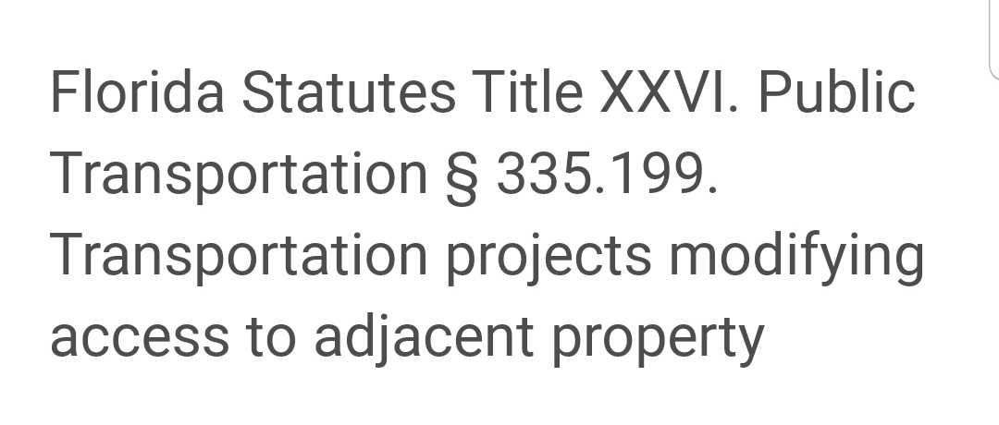

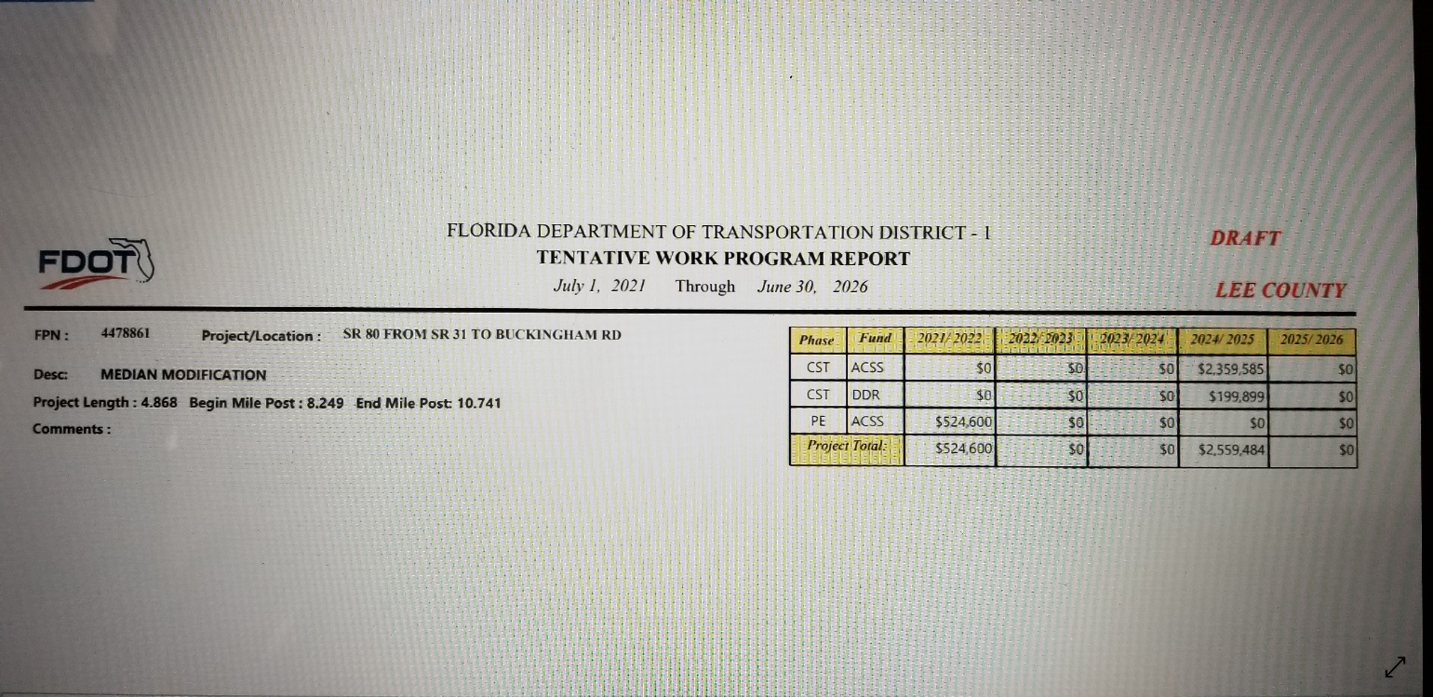

Attachments provided by Mr. John Majka as Public Comment (page 2)

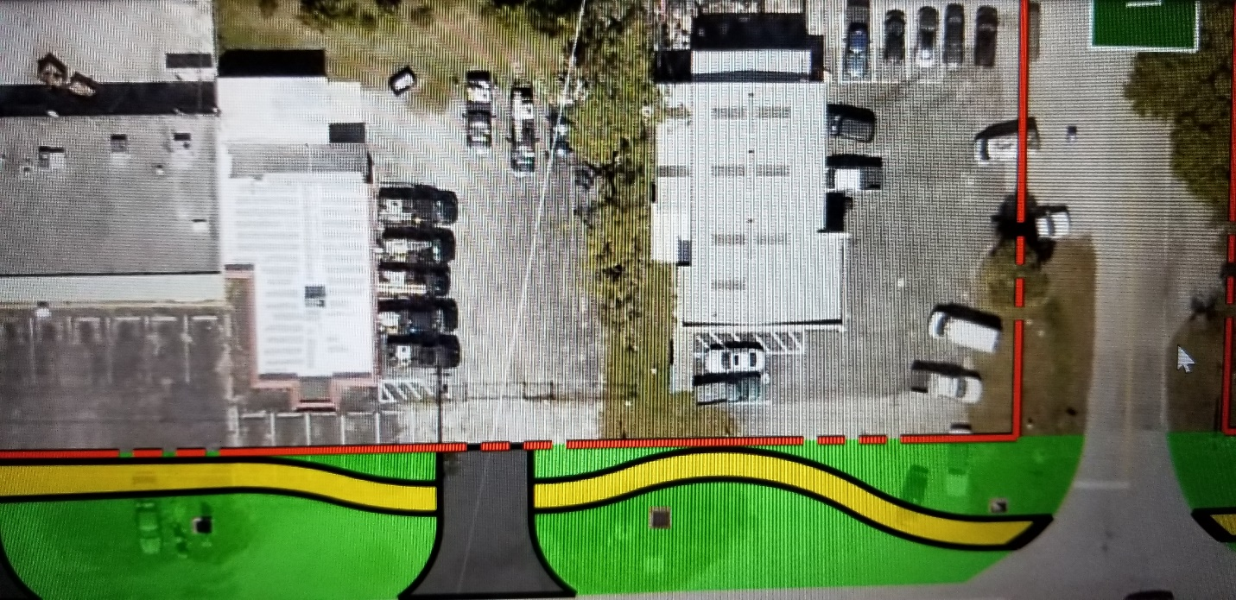

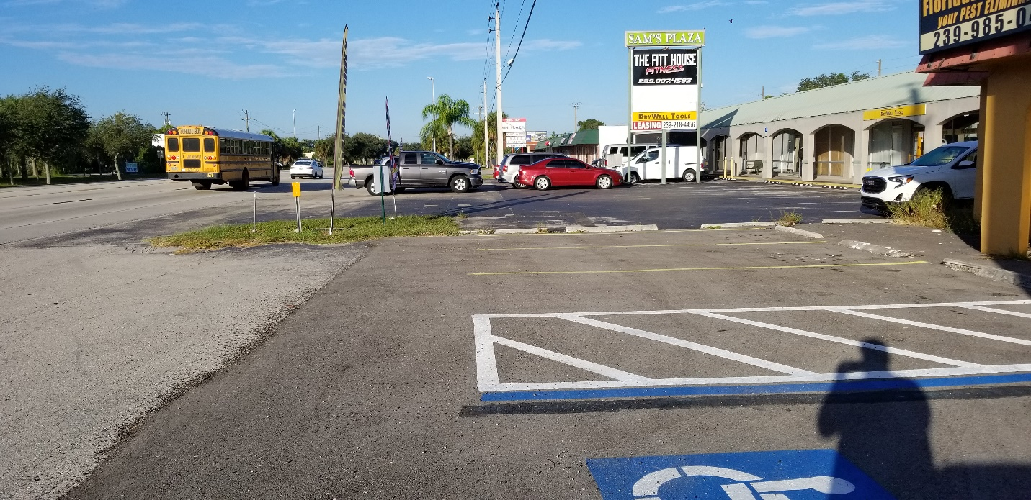

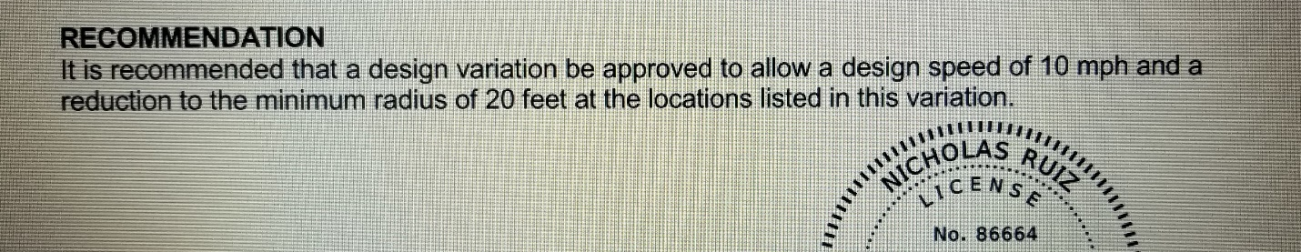

Attachments provided by Mr. John Majka as Public Comment (page 3)

